# REGULATORY REFORM (FIRE SAFETY) ORDER 2005 FIRE RISK ASSESSMENT



**Fire Risk Assessment London Shelton Hotel and Restaurant, Wightman Road, London,**

**N4 1RU**

|  |  |
| --- | --- |
| **Responsible person (e.g. employer) or person** | Landlord |
| **having control of premises:** |
| **Address of premises:** | London Shelton Hotel and Restaurant, Wightman Road, London, N4 1RU |
| **Person(s) consulted:** | Landlord |
| **Assessor:** | Mohammed Shahinul Amin |
| **Assessors statement:** | The purpose of this PAS 79-1:2020 (Annex A) report is to provide a non-invasive assessment of the risk to life from fire in these premises, and, where appropriate, to make recommendations to ensure compliance with fire safety legislation. This report does not address the risk to property or business continuity from fire. I certify that to the best of my knowledge, the information contained in this fire risk assessment is correct, based on  information provided at the time the assessment was undertaken. |
| **Report validated by:** | N/A |
| **Date of fire risk assessment:** | 17/12/24 |
| **Date of previous fire risk assessment:** | N/A |
| **Suggested date for review:** | 16/12/25 |
| **Fire Risk Assessment Review:** | This fire risk assessment should be reviewed by a competent person by the date indicated above or at such earlier time as there is reason to suspect that it is no longer valid, or there has been significant change in the  matters to which it relates, or if a fire occurs. |
| **Report compliance:** | This report is intended to assist you in compliance with Article 9 of the Regulatory Reform (Fire Safety) Order  2005 which requires that a fire risk assessment be carried out. |

|  |  |  |
| --- | --- | --- |
| **1.00** | **THE PREMISES** *(Clause 12)* |  |
| 1.01 | Number of floors at ground level and above: | 3 floors |
| Number of floors entirely below ground level: | 1 floor |
| Floors on which car parking is provided: | 0 floors |
| 1.02 | Approximate floor area per floor: | 40m² per floor. |
| Approximate floor area gross: | 120m² gross. |
| Approximate floor area on ground floor: | 40m² on ground floor. |
| 1.03 | Details of construction and layout: | London Shelton hotel is located in North London and has 30 guest bedrooms. it is located in a busy high street. |
| 1.04 | Occupancy: | members of the public and staff |
| **2.00** | **THE OCCUPANTS** *(Clause 12)* |  |
| 2.01 | Approximate maximum number of employees at any one time: | 10 |
| 2.02 | Approximate maximum number of other occupants at any one time: | 150 |
| 2.03 | Approximate total number of people present in the building at any one time: | 150 |
| **3.00** | **OCCUPANTS ESPECIALLY AT RISK FROM FIRE** *(Clause 12)* |  |
| 3.01 | Sleeping occupants | members of the public and staff |
| 3.02 | Disabled employees: | unknown |
| 3.03 | Other disabled occupants: | unknown |
| 3.04 | Occupants in remote areas and lone workers: | some members of the public |
| 3.05 | Young persons: | members of the public |
| 3.06 | Others: | N/A |
| **4.00** | **FIRE LOSS EXPERIENCE** |  |

|  |  |  |
| --- | --- | --- |
|  |  |  |
| 4.01 | Fires in past 10 years: | N/A |
| 4.02 | Cost of past fire losses: | 0 |
| **5.00** | **OTHER RELEVANT INFORMATION** |  |
| 5.01 | Detail if required: | Grade A Fire Alarm system |
| **6.00** | **RELEVANT FIRE SAFETY LEGISLATION** |  |
| 6.01 | The following fire safety legislation applies to these premises: | Regulatory (Fire Safety) Order 2005 and Building Safety Act 2022. |
| 6.02 | The above legislation is enforced by: | London Fire Brigade |
| 6.03 | Other legislation that makes significant requirements for fire precautions in these premises: | N/A. |
| 6.04 | The other legislation referred to above is enforced by: | Local Authority |
| 6.05 | Is there an alterations notice in force? | N/A |
| 6.06 | Relevant information and deficiencies observed: | Yes |
| 6.07 | Other information: | No |

|  |  |  |  |  |  |
| --- | --- | --- | --- | --- | --- |
| **INDEX** | **DETAIL** | **YES** | **NO** | **N/A** | **CONTROL MEASURES** |
| **7.00** | **ELECTRONIC SOURCES OF IGNITION**  *(Clause 13 and Annex B)* |  |  |  |  |
| 7.01 | Are reasonable measures taken to prevent fires of electrical origin? | ✓ |  |  |  |
| 7.02 | More specifically: |  |  |  |  |
| 7.02 a) | Are fixed installations periodically inspected and  tested? | ✓ |  |  |  |
| 7.02 b) | Is portable appliance testing carried out? | ✓ |  |  |  |
| 7.02 c) | Is there suitable control over the use of personal  electrical appliances? | ✓ |  |  |  |
| 7.02 d) | Is there suitable limitation of trailing leads and  adapters? | ✓ |  |  |  |
|  | Observations: |  |  |  |  |
| **8.00** | **SMOKING**  *(Clause 13 and Annex B)* |  | | | |
| 8.01 | Are reasonable measures taken to prevent fires as a result of smoking? | ✓ |  |  |  |
| 8.02 | More specifically: |  |  |  |  |
| 8.02 a) | Is smoking prohibited in the building? | ✓ |  |  |  |
| 8.02 b) | Is smoking prohibited in appropriate areas? | ✓ |  |  |  |
| 8.02 c) | Are there suitable arrangements for those who  wish to smoke? | ✓ |  |  |  |

|  |  |  |  |  |  |
| --- | --- | --- | --- | --- | --- |
| **INDEX** | **DETAIL** | **YES** | **NO** | **N/A** | **CONTROL MEASURES** |
| 8.02 d) | Did the smoking policy appear to be observed at the time of inspection? | ✓ |  |  |  |
|  | Observations: |  |  |  |  |
| **9.00** | **ARSON**  *(Clause 13 and Annex B)* |  | | | |
| 9.01 | Does basic security against arson by outsiders  appear reasonable? | ✓ |  |  |  |
| 9.02 | Is there an absence of unnecessary fire load in close proximity to the premises or available for  ignition by outsiders? | ✓ |  |  |  |
|  | Observations: |  |  |  |  |
| **10.00** | **PORTABLE HEATERS, HEATING AND VENTILATION SYSTEMS** *(Clause*  *13 and Annex B)* |  | | | |
| 10.01 | Is there satisfactory control over the use of portable  heaters? | ✓ |  |  |  |
| 10.02 | Are fixed heating and ventilation installations  subject to regular maintenance? | ✓ |  |  |  |
|  | Observations: |  |  |  |  |
| **11.00** | **COOKING**  *(Clause 13 and Annex B)* |  | | | |
| 11.01 | Are reasonable measures taken to prevent fires as a result of cooking? | ✓ |  |  |  |
| 11.02 | More specifically, are filters cleaned or changed and ductwork cleaned regularly? | ✓ |  |  | Ducting certificate including TR19 report |
|  | Observations: |  |  |  |  |
| **12.00** | **LIGHTNING**  (Clause 13 and Annex B) |  | | | |
| 12.01 | Does the building have a lightning protection  system? | ✓ |  |  |  |

|  |  |  |  |  |  |
| --- | --- | --- | --- | --- | --- |
| **INDEX** | **DETAIL** | **YES** | **NO** | **N/A** | **CONTROL MEASURES** |
|  | Observations: |  |  |  |  |
| **13.00** | **HOUSEKEEPING**  *(Clause 13 and Annex B)* |  | | | |
| 13.01 | Is the overall standard of housekeeping adequate? | ✓ |  |  |  |
| 13.02 | More specifically: |  |  |  |  |
| 13.02 a) | Do combustible materials appear to be separated from ignition sources? | ✓ |  |  |  |
| 13.02 b) | Is unnecessary accumulation or inappropriate  storage of combustible materials or waste avoided? | ✓ |  |  |  |
|  | Observations: |  |  |  |  |
| **14.00** | **HAZARDS INTRODUCED BY OUTSIDE CONTRACTORS AND BUILDING WORKS**  *(Clause 13 and Annex B)* |  | | | |
| 14.01 | Is there satisfactory control over works carried out  in the building? | ✓ |  |  |  |
| 14.02 | More specifically: |  |  |  |  |
| 14.02 a) | Where appropriate, are fire safety conditions imposed on outside contractors? | ✓ |  |  |  |
| 14.02 b) | Where appropriate, is a permit to work system  used (e.g. for "hot work")? |  |  | ✓ |  |
| 14.02 c) | Are suitable precautions taken by in-house  maintenance personnel who carry out works? | ✓ |  |  |  |
|  | Observations: |  |  |  |  |
| **15.00** | **DANGEROUS SUBSTANCES**  *(Clause 13)* |  | | | |

|  |  |  |  |  |  |
| --- | --- | --- | --- | --- | --- |
| **INDEX** | **DETAIL** | **YES** | **NO** | **N/A** | **CONTROL MEASURES** |
| 15.01 | Are the general fire precautions adequate to address the hazards associates with dangerous substances used or stored within the premises? |  |  | ✓ |  |
|  | Observations: |  |  |  |  |
| 16.00 | **OTHER SIGNIFICANT FIRE HAZARDS THAT**  **WARRANT CONSIDERATION** |  |  |  |  |
| 16.01 | **Hazards:** |  |  |  |  |

|  |  |  |  |  |  |
| --- | --- | --- | --- | --- | --- |
| **INDEX** | **DETAIL** | **YES** | **NO** | **N/A** | **CONTROL MEASURES** |
| **17.00** | **MEANS OF ESCAPE**  *(Clause 15c) and Annex C)* |  |  |  |  |
| 17.01 | Is the design and maintenance of the means of  escape considered adequate? | ✓ |  |  |  |
| 17.02 | More Specifically: |  |  |  |  |
| 17.02 a) | Do staircase and exit capacities appear to be  adequate for the number of occupants? | ✓ |  |  |  |
| 17.02 b) | Are there reasonable distances of travel: |  |  |  |  |
| 17.02 b1) | Where there is escape in a single direction? | ✓ |  |  |  |
| 17.02 b2) | Where there are alternative means of escape? | ✓ |  |  |  |
| 17.02 c) | Is there adequate provision of exits? | ✓ |  |  |  |
| 17.02 d) | Do fire exits open in the direction of escape, where  necessary? | ✓ |  |  |  |
| 17.02 e) | Are there satisfactory arrangements for escape where revolving or sliding doors are used as exits? |  |  | ✓ |  |
| 17.02 f) | Are the arrangements provided for securing exits  satisfactory? | ✓ |  |  |  |
| 17.02 g) | Is a suitable standard of protection designed for  escape routes? | ✓ |  |  |  |
| 17.02 h) | Are there reasonable arrangements for means of escape for disabled people? | ✓ |  |  |  |
| 17.03 | Are the escape routes available for use and  suitably maintained? | ✓ |  |  |  |
| 17.04 | More Specifically: |  |  |  |  |

|  |  |  |  |  |  |
| --- | --- | --- | --- | --- | --- |
| **INDEX** | **DETAIL** | **YES** | **NO** | **N/A** | **CONTROL MEASURES** |
| 17.04 a) | Are fire-resisting doors maintained in sound condition and self closing, where necessary? | ✓ |  |  |  |
| 17.04 b) | Is the fire-resisting construction protecting escape  routes in sound condition? | ✓ |  |  |  |
| 17.04 c) | Are all escape routes clear of obstructions? | ✓ |  |  |  |
| 17.04 d) | Are all fire exits easily and immediately openable? | ✓ |  |  |  |
|  | Observations: |  |  |  |  |
| **18.00** | **MEASURES TO LIMIT FIRE SPREAD AND DEVELOPMENT**  *(Clause 15g)* |  |  |  |  |
| 18.01 | Is it considered that there is: |  |  |  |  |
| 18.01 a) | Compartmentation of a reasonable standard? | ✓ |  |  |  |
| 18.01 b) | Reasonable limitation of linings that may promote fire spread? | ✓ |  |  |  |
| 18.02 | As far as can be reasonably be ascertained, are fire dampers provided necessary to protect critical means of escape against passage of fire, smoke and products of combustion in the early stages of a  fire? | ✓ |  |  |  |
|  | Observations: |  |  |  |  |
| **19.00** | **EMERGENCY ESCAPE LIGHTING**  *(Clause 15e)* |  |  |  |  |
| 19.01 | Has a reasonable standard of emergency escape  lighting system been provided? | ✓ |  |  |  |

|  |  |  |  |  |  |
| --- | --- | --- | --- | --- | --- |
| **INDEX** | **DETAIL** | **YES** | **NO** | **N/A** | **CONTROL MEASURES** |
|  | Observations: |  |  |  |  |
| **20.00** | **FIRE SAFETY SIGNS AND NOTICES**  *(Clause 15d)* |  |  |  |  |
| 20.01 | Is there a reasonable standard of fire safety signs  and notices? | ✓ |  |  |  |
|  | Observations: |  |  |  |  |
| **21.00** | **MEANS OF GIVING WARNING IN CASE OF FIRE**  *(Clause 15b)* |  |  |  |  |
| 21.01 | Is a reasonable fire detection and fire alarm system provided? | ✓ |  |  |  |
| 21.02 | Is there remote transmission of alarm signals? |  |  | ✓ |  |
| 21.03 | Is a zone plan of the fire alarm system displayed? |  | ✓ |  | Consider providing a zone plan of the system adjacent to the fire control panel. |
| 21.04 | Has the premises had false alarms experience? |  | ✓ |  | Reduce false alarms by replacing smoke detector with a heat detector in the  kitchen. |
|  | Observations: |  |  |  |  |
| **22.00** | **MANUAL FIRE EXTINGUISHING APPLIANCES**  *(Clause 15f)* |  |  |  |  |
| 22.01 | Is there reasonable provision of manual fire  extinguishing appliances? | ✓ |  |  |  |
| 22.02 | What type(s) of appliances are provided: |  |  |  |  |
| 22.02 a) | Portable fire extinguishers: | ✓ |  |  |  |
| 22.02 b) | Hose reels: |  |  | ✓ |  |
| 22.02 c) | Fire blankets: | ✓ |  |  |  |
| 22.03 | Are all fire extinguishing appliances readily  accessible? | ✓ |  |  |  |
|  | Observations: |  |  |  |  |

|  |  |  |  |  |  |
| --- | --- | --- | --- | --- | --- |
| **INDEX** | **DETAIL** | **YES** | **NO** | **N/A** | **CONTROL MEASURES** |
| **23.00** | **RELEVANT AUTOMATIC FIRE EXTINGUISHING SYSTEMS**  *(Clause 15h)* |  |  |  |  |
| 23.01 | Type of fixed system(s): |  |  |  |  |
| 23.01 a) | Sprinkler system? |  |  | ✓ |  |
| 23.01 b) | Misting system? |  |  | ✓ |  |
| 23.01 c) | Kitchen suppression system? |  |  | ✓ |  |
| 23.01 d) | Inert gas flooding system? |  |  | ✓ |  |
|  | Observations: (*List fixed systems)* |  |  |  |  |
| **24.00** | **OTHER RELEVANT FIXED SYSTEMS AND EQUIPMENT**  *(Clause 15i)* |  |  |  |  |
| 24.01 | Type of other fixed system(s) installed: |  |  | ✓ |  |
| 24.02 | Is there suitable provisions of firefighters'  switch(es) for high voltage isolation of luminous tube signs, etc.? |  |  | ✓ |  |
| 24.03 | Are there appropriately sited facilities for electrical isolation of any photovoltaic (PV) cells, with appropriate signage, to assist the fire and rescue  service? |  |  | ✓ |  |
|  | Observations: |  |  |  |  |

|  |  |  |  |  |  |
| --- | --- | --- | --- | --- | --- |
| **INDEX** | **DETAIL** | **YES** | **NO** | **N/A** | **CONTROL MEASURES** |
| **25.00** | **PROCEDURES AND ARRANGEMENTS** *(Clause*  *16)* |  |  |  |  |
| 25.01 | Safety assistance: | ✓ |  |  | The competent person(s) appointed under Article 18 of the Fire Safety Order to assist the responsible person in undertaking the preventive and protection measures (i.e. relevant general fire precautions) is Landlord. |
| 25.02 | Fire safety at the premises is managed by: | ✓ |  |  | The fire safety at the premises is managed by Landlord. |
| 25.03 | Is there a suitable record of the fire safety  arrangements? |  | ✓ |  | Review fire emergency plan to detail required fire safety arrangements. |
| 25.04 | Are procedures in the event of fire appropriate and  properly documented, where appropriate? |  | ✓ |  | Formulate and document fire procedures for the premises. |
|  | More specifically: |  |  |  |  |
| 25.04 a) | Are there adequate procedures for investigating fire  alarm signals? | ✓ |  |  |  |
| 25.04 b) | Are there suitable arrangements for summoning  the fire and rescue service? | ✓ |  |  |  |
| 25.04 c) | Are there suitable arrangements to meet the fire and rescue service on arrival and provide them with relevant information, including that relating to  hazards to firefighters? | ✓ |  |  |  |
| 25.04 d) | Are there suitable arrangements for ensuring that  the premises have been evacuated? | ✓ |  |  |  |
| 25.04 e) | Is there suitable fire assembly point(s)? | ✓ |  |  |  |
| 25.04 f) | Are there adequate procedures for evacuation of  any disabled people who are likely to be present? | ✓ |  |  |  |
| 25.05 | Are there persons nominated and trained to use  fire extinguishing appliances? | ✓ |  |  |  |
| 25.06 | If the premises are in multiple occupation, are there adequate arrangements for cooperation between duty holders to ensure coordination of their fire  safety arrangements? |  |  | ✓ |  |
| 25.07 | Are there persons nominated to assist with  evacuation of disabled people? | ✓ |  |  |  |

|  |  |  |  |  |  |
| --- | --- | --- | --- | --- | --- |
| **INDEX** | **DETAIL** | **YES** | **NO** | **N/A** | **CONTROL MEASURES** |
| 25.08 | Is there appropriate liaison with the fire and rescue  service (i.e. by fire and rescue service crews visiting for familiarization visits? |  | ✓ |  | Arrange for the local fire and rescue service to carry out pre-fire inspections of the premises. |
| 25.09 | Are routine in-house inspections of fire precautions undertaken (e.g. in the course of health and safety  inspections? | ✓ |  |  | Ensure that all required routine fire inspections are carried out. |
|  | Observations: |  |  |  |  |
| **26.00** | **TRAINING AND DRILLS** *(Clause 16h)* |  |  |  |  |
| 26.01 | Are all staff given adequate fire safety instruction  and training on induction? | ✓ |  |  |  |
|  | More specifically: |  |  |  |  |
| 26.01 a) | Are they trained on induction? | ✓ |  |  |  |
| 26.01 b) | Are they given periodic refresher training? | ✓ |  |  |  |
| 26.01 c) | Are they given additional training to cover any  specific roles and responsibilities? | ✓ |  |  |  |
| 26.01 d) | Is the content of the training provided considered  adequate? | ✓ |  |  |  |
| 26.02 | Are fire drills carried out at appropriate intervals? | ✓ |  |  |  |
| 26.03 | When the employees of another employer work in the premises, is appropriate information on the fire  risks and fire safety measures provided? |  |  | ✓ |  |
|  | Observations: |  |  |  |  |
| **27.00** | **TESTING AND MAINTENANCE** *(Clause 16j)* |  |  |  |  |
| 27.01 | Is there adequate maintenance of the premises? | ✓ |  |  |  |
| 27.02 | Is weekly testing and periodic servicing of fire  detection and alarm system undertaken? |  | ✓ |  | Senior fire marshal to ensure that weekly fire alarm test and periodic servicing are  carried out and recorded by competent persons. |
| 27.03 | Is monthly and annual testing routines for  emergency lighting? |  | ✓ |  | Senior fire marshal to ensure that monthly and annual emergency lighting tests are  carried out and recorded by competent persons. |

|  |  |  |  |  |  |
| --- | --- | --- | --- | --- | --- |
| **INDEX** | **DETAIL** | **YES** | **NO** | **N/A** | **CONTROL MEASURES** |
| 27.04 | Is annual maintenance of fire extinguishing  appliances undertaken? | ✓ |  |  |  |
| 27.05 | Is periodic inspection of external escape staircases  and gangways undertaken? | ✓ |  |  |  |
| 27.06 | Are six-monthly inspection and annual testing of  rising mains undertaken? |  |  | ✓ |  |
| 27.07 | Are weekly and monthly testing, six monthly inspection and annual testing of fire-fighting lift(s) provided for the use by firefighters or evacuation of  disabled people (evacuation lifts)? |  |  | ✓ |  |
| 27.08 | Are weekly testing and periodic inspection of  sprinkler installations undertaken? |  |  | ✓ |  |
| 27.09 | Are routine checks of final exit doors and/or  security fastenings undertaken? | ✓ |  |  |  |
| 27.10 | Is an annual inspection of lightning protection  system undertaken? | ✓ |  |  |  |
| 27.11 | Other relevant inspections or tests? |  |  |  |  |
|  | Observations: |  |  |  |  |
| **28.00** | **RECORDS** *(Clause 16k)* |  |  |  |  |
| 28.01 | Are there appropriate records of: |  |  |  |  |
| 28.01 a) | Fire drills? |  | x |  | Provide and maintain a register of records for fire drills. |
| 28.01 b) | Fire Training? |  | x |  | Provide and maintain a register of records for fire training. |
| 28.01 c) | Fire alarm tests? |  | x |  | Provide and maintain a register of records for fire alarm tests. |
| 28.01 d) | False alarms? |  | x |  | Provide and maintain a register of records for false alarms. |
| 28.01 e) | Emergency escape lighting tests? |  | x |  | Provide and maintain a register of records for emergency lighting tests. |
| 28.01 f) | Maintenance and testing of other fixed fire  protection systems? |  | x |  | Provide and maintain a register of records for fixed fire system tests. |
| 28.01 g) | Is the fire emergency plan for the premises  adequate? |  | x |  | Review and add more relevant detail to the fire emergency plan. |
| 29.09 | Is the fire emergency plan available to the  enforcing authority? |  | x |  | Ensure that fire emergency plan is readily available for enforcing authority  inspection. |

|  |  |  |  |  |  |
| --- | --- | --- | --- | --- | --- |
| **INDEX** | **DETAIL** | **YES** | **NO** | **N/A** | **CONTROL MEASURES** |
| 29.10 | Are Personal Emergency Evacuation Plans (PEEPS) required and in place? |  | x |  | Ensure that Personal Emergency Evacuation Plans are compiled in accordance  with Home Office guidance and is readily available for enforcing authority inspection. |
|  | Observations: |  |  |  |  |

**Risk Value Matrix**

FIRE RISK ASSESSMENT RISK REGISTER

|  |  |  |
| --- | --- | --- |
| **Likelihood** | **Value** | **Severity of Outcome(s)** |
| Negligible | 1 | Negligible |
| Low | 2 | Minor injury to occupants, first aid required |
| Moderate | 3 | Moderate Injury to occupants, medical attention required. |
| High | 4 | Occupants required hospitalisation. |
| Extreme | 5 | Major loss of life. |

**Severity**

**Likelihood**

|  |  |  |  |  |
| --- | --- | --- | --- | --- |
| 1 | 2 | 3 | 4 | 5 |
| 2 | 4 | 6 | 8 | 10 |
| 3 | 6 | 9 | 12 | 15 |
| 4 | 8 | 12 | 16 | 20 |
| 5 | 10 | 15 | 20 | 25 |

Likelihood Severity

|  |
| --- |
| Risk Rating Score: |
| 4 |

2

2

|  |  |
| --- | --- |
| Risk Rating | Action PAS 79-1:2020 |
| Trivial | Record findings and review in 12 months |
| Tolerable | No major additional controls required. However, There might be a need for improvements that involve minor or limited costs. |
| Moderate | It is essential that efforts are made to reduce the risk. Risk reduction measures should be implemented within a defined time period. |
| Where moderate risk is associated with consequences that constitute extreme harm, further assessment might be required to establish more precisely the likelihood of harm as a basis for determining the priority for improved control measures. |
| Substantial | Considerable resources might have to be allocated to reduce the risk. If the building is unoccupied, it should not be occupied until the risk has been reduced. If the building is occupied, urgent action should be taken. |
| Intolerable | Building (or relevant area) should not be occupied until the risk is reduced. |

|  |
| --- |
| **Fire Risk Assessment Review** |
| ***Assessments should be kept under constant review, and in any case reviewed whenever circumstance change which affect the validity of the current assessment. Whilst there is no maximum period between assessments, it is recommended that the review period should not exceed 12 months.*** |

FIRE RISK ASSESSMENT ACTION PLAN

|  |  |  |  |  |
| --- | --- | --- | --- | --- |
| **QUESTION** | **SIGNIFICANT FINDINGS / ACTION PLAN** | **RESPONSIBLE**  **PERSON** | T**ARGET DATE** | **DATE COMPLETED &**  **INITIAL** |
| 25.08 | Arrange for the local fire and rescue service to carry out pre-fire inspections of the  premises. | Landlord | Continuously |  |
| 25.09 | Ensure that all required routine fire inspections are carried out. | Landlord | Continuously |  |
| 26.00 | **TRAINING AND DRILLS** *(Clause 16h)* |  |  |  |
|  |  |  |  |  |
|  |  |  |  |  |
|  |  |  |  |  |
|  |  |  |  |  |
|  |  |  |  |  |
|  |  |  |  |  |
|  |  |  |  |  |
| 27.00 | **TESTING AND MAINTENANCE** *(Clause 16j)* |  |  |  |
|  |  |  |  |  |
|  |  |  |  |  |
|  |  |  |  |  |
|  |  |  |  |  |
|  |  |  |  |  |
|  |  |  |  |  |
|  |  |  |  |  |
|  |  |  |  |  |
|  |  |  |  |  |
|  |  |  |  |  |
|  |  |  |  |  |
| 28.00 | **RECORDS** *(Clause 16k)* |  |  |  |
| 28.01 a) | Provide and maintain a register of records for fire drills. | Landlord | Continuously |  |
| 28.01 b) | Provide and maintain a register of records for fire training. | Landlord | Continuously |  |
| 28.01 c) | Provide and maintain a register of records for fire alarm tests. | Landlord | Continuously |  |
| 28.01 d) | Provide and maintain a register of records for false alarms. | Landlord | Continuously |  |
| 28.01 e) | Provide and maintain a register of records for emergency lighting tests. | Landlord | Continuously |  |

# PHOTOGRAPHS -

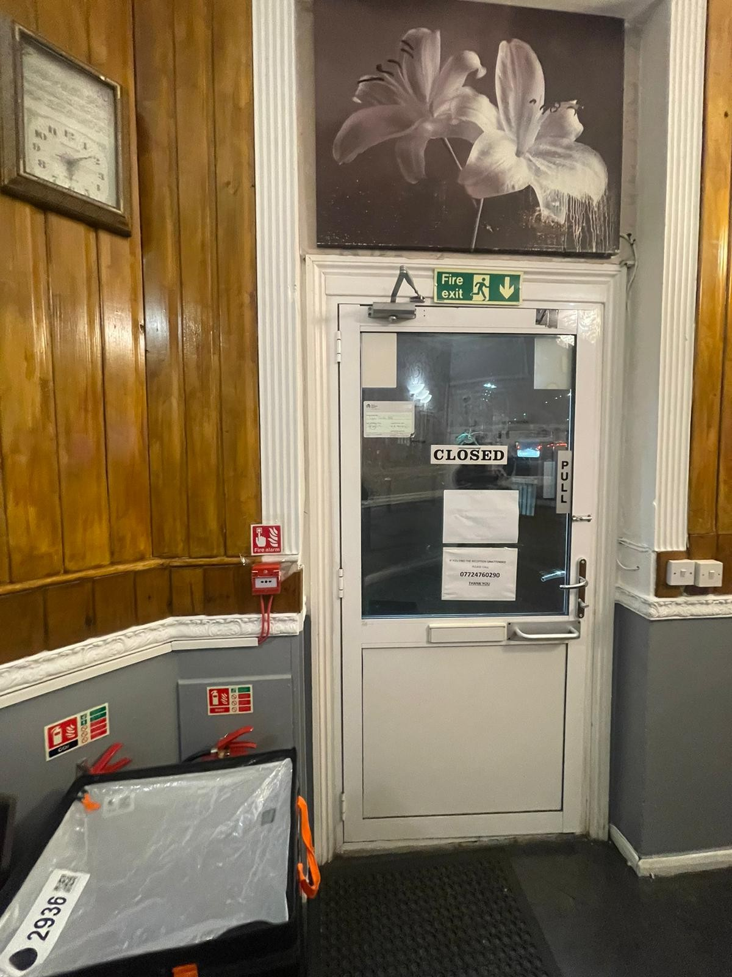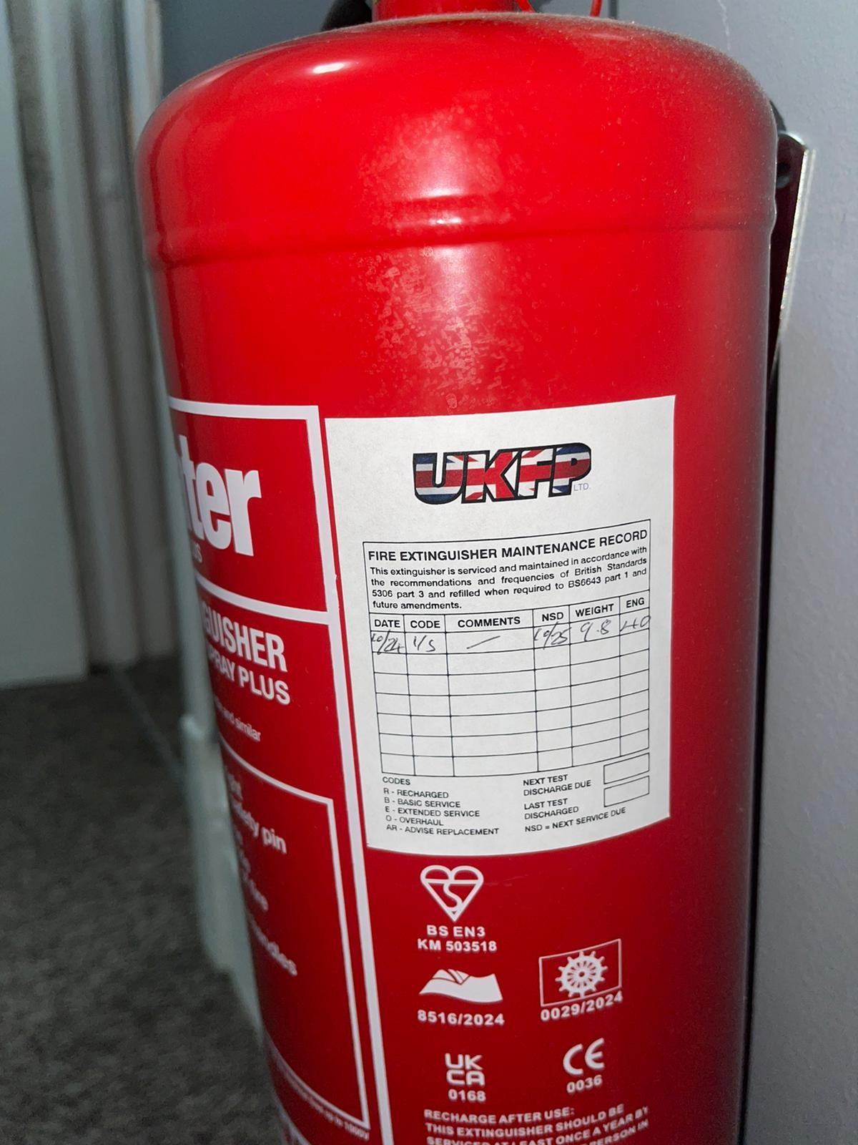

Photograph 1- shows self closing devices fitted on appropriate doors to help prevent the spread of fires. Appropriate signs such as fire exit doors were placed around the premises.

### 1.00 THE PREMISES (Clause 12)

1.01 What is the number of floors at ground level and above?  
1.02 What is the approximate floor area per floor?  
1.03 What are the details of construction and layout of the premises?  
1.04 What is the occupancy of the premises?

### 2.00 THE OCCUPANTS (Clause 12)

2.01 What is the approximate maximum number of employees at any one time?  
2.02 What is the approximate maximum number of other occupants at any one time?  
2.03 What is the approximate total number of people present in the building at any one time?

### 3.00 OCCUPANTS ESPECIALLY AT RISK FROM FIRE (Clause 12)

3.01 Who are the sleeping occupants?  
3.02 Who are the disabled employees?  
3.03 Who are the other disabled occupants?  
3.04 Who are the occupants in remote areas and lone workers?  
3.05 Who are the young persons?  
3.06 Are there any other at-risk occupants?

### 4.00 FIRE LOSS EXPERIENCE

4.01 Have there been any fires in the past 10 years?  
4.02 What is the cost of past fire losses?

### 5.00 OTHER RELEVANT INFORMATION

5.01 Is further detail required?

### 6.00 RELEVANT FIRE SAFETY LEGISLATION

6.01 What fire safety legislation applies to these premises?  
6.02 Who enforces the above legislation?  
6.03 What other legislation makes significant requirements for fire precautions in these premises?  
6.04 Who enforces the other relevant legislation?  
6.05 Is there an alterations notice in force?  
6.06 What relevant information and deficiencies have been observed?  
6.07 Is there any other relevant information?

### 7.00 ELECTRONIC SOURCES OF IGNITION (Clause 13 and Annex B)

7.01 Are reasonable measures taken to prevent fires of electrical origin?  
7.02 More specifically:  
7.02 a) Are fixed installations periodically inspected and tested?  
7.02 b) Is portable appliance testing carried out?  
7.02 c) Is there suitable control over the use of personal electrical appliances?  
7.02 d) Is there suitable limitation of trailing leads and adapters?

### 8.00 SMOKING (Clause 13 and Annex B)

8.01 Are reasonable measures taken to prevent fires as a result of smoking?  
8.02 More specifically:  
8.02 a) Is smoking prohibited in the building?  
8.02 b) Is smoking prohibited in appropriate areas?  
8.02 c) Are there suitable arrangements for those who wish to smoke?  
8.02 d) Did the smoking policy appear to be observed at the time of inspection?

### 9.00 ARSON (Clause 13 and Annex B)

9.01 Does basic security against arson by outsiders appear reasonable?  
9.02 Is there an absence of unnecessary fire load in close proximity to the premises or available for ignition by outsiders?

### 10.00 PORTABLE HEATERS, HEATING AND VENTILATION SYSTEMS (Clause 13 and Annex B)

10.01 Is there satisfactory control over the use of portable heaters?  
10.02 Are fixed heating and ventilation installations subject to regular maintenance?

### 11.00 COOKING (Clause 13 and Annex B)

11.01 Are reasonable measures taken to prevent fires as a result of cooking?  
11.02 More specifically, are filters cleaned or changed and ductwork cleaned regularly?

### 12.00 LIGHTNING (Clause 13 and Annex B)

12.01 Does the building have a lightning protection system?

### 13.00 HOUSEKEEPING (Clause 13 and Annex B)

13.01 Is the overall standard of housekeeping adequate?  
13.02 More specifically:  
13.02 a) Do combustible materials appear to be separated from ignition sources?  
13.02 b) Is unnecessary accumulation or inappropriate storage of combustible materials or waste avoided?

### 14.00 HAZARDS INTRODUCED BY OUTSIDE CONTRACTORS AND BUILDING WORKS (Clause 13 and Annex B)

14.01 Is there satisfactory control over works carried out in the building?  
14.02 More specifically:  
14.02 a) Where appropriate, are fire safety conditions imposed on outside contractors?  
14.02 b) Where appropriate, is a permit to work system used (e.g. for "hot work")?  
14.02 c) Are suitable precautions taken by in-house maintenance personnel who carry out works?

### 15.00 DANGEROUS SUBSTANCES (Clause 13)

15.01 Are the general fire precautions adequate to address the hazards associated with dangerous substances used or stored within the premises?

### 16.00 OTHER SIGNIFICANT FIRE HAZARDS THAT WARRANT CONSIDERATION

16.01 What are the other significant fire hazards?

### 17.00 MEANS OF ESCAPE (Clause 15c and Annex C)

17.01 Is the design and maintenance of the means of escape considered adequate?  
17.02 More specifically:  
17.02 a) Do staircase and exit capacities appear to be adequate for the number of occupants?  
17.02 b) Are there reasonable distances of travel:  
17.02 b1) Where there is escape in a single direction?  
17.02 b2) Where there are alternative means of escape?  
17.02 c) Is there adequate provision of exits?  
17.02 d) Do fire exits open in the direction of escape, where necessary?  
17.02 e) Are there satisfactory arrangements for escape where revolving or sliding doors are used as exits?  
17.02 f) Are the arrangements provided for securing exits satisfactory?  
17.02 g) Is a suitable standard of protection designed for escape routes?  
17.02 h) Are there reasonable arrangements for means of escape for disabled people?  
17.03 Are the escape routes available for use and suitably maintained?  
17.04 More specifically:  
17.04 a) Are fire-resisting doors maintained in sound condition and self-closing, where necessary?  
17.04 b) Is the fire-resisting construction protecting escape routes in sound condition?  
17.04 c) Are all escape routes clear of obstructions?  
17.04 d) Are all fire exits easily and immediately openable?

### 18.00 MEASURES TO LIMIT FIRE SPREAD AND DEVELOPMENT (Clause 15g)

18.01 Is it considered that there is:  
18.01 a) Compartmentation of a reasonable standard?  
18.01 b) Reasonable limitation of linings that may promote fire spread?  
18.02 As far as can be reasonably ascertained, are fire dampers provided necessary to protect critical means of escape against passage of fire, smoke, and products of combustion in the early stages of a fire?

### 19.00 EMERGENCY ESCAPE LIGHTING (Clause 15e)

19.01 Has a reasonable standard of emergency escape lighting system been provided?

### 20.00 FIRE SAFETY SIGNS AND NOTICES (Clause 15d)

20.01 Is there a reasonable standard of fire safety signs and notices?

### 21.00 MEANS OF GIVING WARNING IN CASE OF FIRE (Clause 15b)

21.01 Is a reasonable fire detection and fire alarm system provided?  
21.02 Is remote transmission of alarm signals available?  
21.03 Is a zone plan of the fire alarm system displayed?  
21.04 Has the premises had false alarms experience?

### 22.00 MANUAL FIRE EXTINGUISHING APPLIANCES (Clause 15f)

22.01 Is there reasonable provision of manual fire extinguishing appliances?  
22.02 What type(s) of appliances are provided:  
22.02 a) Portable fire extinguishers?  
22.02 b) Hose reels?  
22.02 c) Fire blankets?  
22.03 Are all fire extinguishing appliances readily accessible?

### 23.00 RELEVANT AUTOMATIC FIRE EXTINGUISHING SYSTEMS (Clause 15h)

23.01 What type of fixed system(s) are installed?  
23.01 a) Sprinkler system?  
23.01 b) Misting system?  
23.01 c) Kitchen suppression system?  
23.01 d) Inert gas flooding system?

### 24.00 OTHER RELEVANT FIXED SYSTEMS AND EQUIPMENT (Clause 15i)

24.01 What type of other fixed system(s) is installed?  
24.02 Is there suitable provision of firefighter's switch(es) for high voltage isolation of luminous tube signs, etc.?  
24.03 Are there appropriately sited facilities for electrical isolation of any photovoltaic (PV) cells, with appropriate signage, to assist the fire and rescue service?

### 25.00 PROCEDURES AND ARRANGEMENTS (Clause 16)

25.01 Who is the competent person(s) appointed to assist the responsible person in undertaking preventive and protection measures (i.e. relevant general fire precautions)?  
25.02 Who manages fire safety at the premises?  
25.03 Is there a suitable record of the fire safety arrangements?  
25.04 Are procedures in the event of fire appropriate and properly documented, where appropriate?  
25.05 Are there persons nominated and trained to use fire extinguishing appliances?  
25.06 If the premises are in multiple occupation, are there adequate arrangements for cooperation between responsible persons?  
25.07 Are there adequate arrangements for co-operation in the event of a fire between the person responsible for each building, or each part of a building, in the same building complex?

### 26.00 FIRE DRILLS AND FIRE SAFETY TRAINING (Clause 17)

26.01 Are regular fire drills carried out?  
26.02 Is there suitable fire safety training for all employees?  
26.03 Is there suitable fire safety training for temporary employees?  
26.04 Is there suitable fire safety training for new employees?  
26.05 Is there suitable fire safety training for employees assigned to special tasks?

### 27.00 FIRE SAFETY AUDIT (Clause 17)

27.01 Is a fire safety audit carried out at appropriate intervals?